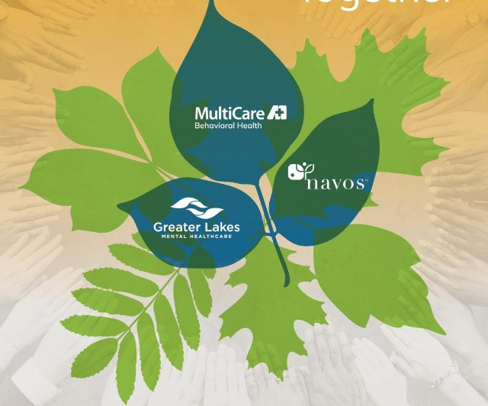
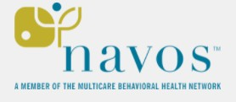

NAVOS HOSPITAL

2022 Community Health

Implementation Strategy

Table of Contents
Our Hospital, Programs, and People Served Page 3
Our Services Page 3
Our Mission, Vision, and Values Page 3
Description of the Community Served Page 4

Community Health Needs Assessment Page 5
Leading Causes of Hospitalization Page 6
Mental Health and Substance Use Page 7
Significant Health Needs Page 7
Implementation Strategy Page 8
Creating the Implementation Strategy Page 8
Strategies by Health Need Page 9

At-A-Glance Page 13
Navos Mental Health and Wellness Board of Directors Page 14
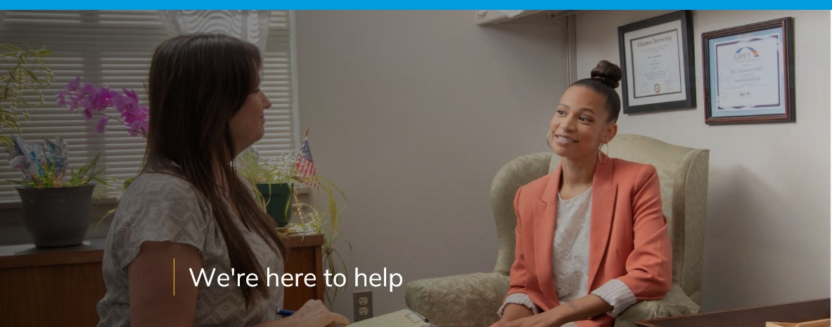

Our Hospital, Programs, and People Served

Our Services
Navos Mental Health Solutions is part of the MultiCare Behavioral Health Network. There are three main campuses including a freestanding, 3 story, behavioral health hospital with 70 inpatient beds located in West Seattle. The hospital provides services to adults ages 18 and over with a focus on psychiatric care for individuals who are involuntary detained. Navos serves the residents of King County, however, can accept and assist other residents within different counties of Washington. Navos Hospital serves patients on both long-term and short-term involuntary commitments.
The Mental Health and Wellness Center is located in Burien and provides outpatient mental health and substance use disorder (SUD) services to all ages. The Burien Campus is also home to our Program for Assertive Community Treatment or PACT Team, serving up to 90 adult clients within Navos housing units, private residences, or who are unhoused or homeless. Navos Outpatient also has an Expanded Community Service Program, serving up to 38 adult clients in Navos residential housing located in West Seattle and surrounding area.

The Lake Burien Campus is home to our outpatient youth services. This campus provides services to youth, aged 0-18.

Our Mission, Vision, and Values

Mission: Our mission is to transform the quality of life for people vulnerable to mental illness and substance abuse disorders by providing a broad continuum of integrated, high value behavioral health services for the people within the communities of King County. We believe that diversity, inclusion, and equity are vital to living our values and achieving our mission.

Vision: We believe all people with a mental illness or substance use disorder can lead meaningful lives and successfully manage their illnesses. We provide treatment tailored for each client’s particular needs. We believe that each of our clients, regardless of their situation, should have as much control of their lives as their illness allows. We work closely with clients to develop their individual goals and treatment plan; even the most seriously ill clients participate in their own care.

Values:

We choose HOPE.

We embrace DIVERSITY.

We EMPOWER the individual.

We provide COMPASSIONATE CARE.

We do WHAT IS RIGHT.

We deliver COORDINATED SERVICES.

WE ALL HAVE A RIGHT TO A QUALITY OF LIFE.

We are NAVOS.

DESCRIPTION OF THE COMMUNITY SERVED
Navos is located in Seattle, WA and primarily serves individuals residing in King County who have received an involuntary treatment order for psychiatric care in an inpatient setting. Although Navos can and does serve patients from other Washington counties, the vast majority of patients admitted reside in King County. Navos primarily serves patients receiving Medicaid.
King County includes 38 cities and towns and is divided into four geographic areas: Seattle, North, South, and East. King County has 19 public school districts, (not including private and charter schools and the Muckleshoot Tribal School) and numerous mental health and physical health systems across the county.
Based on the 2018 Census, King County was home to 2,190,200 residents doubling the reported census in 1990. King County has seen a growth in diversity. King County is now 60% white compared to 62% in 2016. The Asian population has grown from 16-18% and more than ½ of King County children are children of color. The King County Community Health Needs Assessment provides the following statistics for King County residents based on the 2018 Census:

White/non-Hispanic 47%
Asian/non-Hispanic 17%
Hispanic/Latino 16%
Multiple Race 10%
Black/African American non-Hispanic 8%
American Indian/Alaska Native/ non-Hispanic 1%
Native Hawaiian/Pacific Islander/non-Hispanic 1%

COMMUNITY HEALTH NEEDS ASSESSMENT

Understanding the needs of our community strengthens our ability to carry out the mission, vision, and values of our organization. The King County Community Health and Needs Assessment provides important information and guidance about the community we serve and supports us in partnering with that community in healing and having a healthy future.

Navos is a member of the King County Hospitals for a Healthier Community or HHC. As part of the HHC, Navos partnered with King County and King County non-profit hospitals to conduct a Community Health Needs Assessment (CHNA). We collaborated with these hospitals and King County Public Health to gather community input, identify stakeholder organizations, describe impacts of programs, and measure program indicators. The CHNA presents a detailed description of the community, analyses of data on life expectancy and leading causes of death, a review of levels of chronic illness, access to services, mental health and substance use, and the Medicaid population throughout King County. In addition, this report provides quantitative information about additional community health needs that were identified by the Hospitals for Healthier Community.

A summary description of the King County community is below, based on data reported in the 2021/2022 CHNA. Additional details can be found in the CHNA report online @ King County Community Health Needs Assessment, 2021-2022.

The 2021/2022 CHNA provides the following information related to King County residents:

In 2020, 1 in 3 King County residents, or 35.5%, filed initial unemployment insurance claims
22.4% of King County residents were limited in some way due to a physical, mental or emotional disability. The rate of disability is significantly higher with adult residents identifying as lesbian, gay, or bi-sexual at 29.5%
Nearly 40% of Black adults are food insecure
King County is seeing escalating housing expenses for both owners and renters. Housing costs for male residents were greatly impacted by COVID-19 and created more disparity for male residents
11,199 individuals, youth, and members of families are experiencing homelessness in Seattle/King County – Among the King County homeless population, 70% lives in Seattle. The overall homeless population in King County disproportionately impacts people and households of color

LEADING CAUSES OF HOSPITALIZATION

The 2021/2022 CHNA averaged data from 2016-2018 to determine the leading causes for hospitalization. This information helps inform the inpatient healthcare delivery system in King County about the impacts of chronic disease and injuries on the health care system. Below are the identified leading causes for hospitalization, which include both mental and physical illnesses:

Among adults, the top 3 leading causes of hospitalization were unintentional injury, septicemia, and osteoarthritis

Schizophrenia and other psychotic disorders were the 3rd leading cause of hospitalization for residents from high-poverty neighborhoods, 6th leading cause overall

Children ages 1-4 were most often hospitalized for asthma, unintentional injuries and depression

For adolescents and young adults, aged 15-24, the leading causes for hospitalization were depressive disorders, complications during childbirth, and schizophrenia and other psychotic disorders

MENTAL HEALTH AND SUBSTANCE USE

The 2021/2022 CHNA reports that mental illness can increase the likelihood of individuals having physical health problems and chronic health conditions such as heart disease and type 2 diabetes. Additionally, “high- income adults are nearly twice as likely to have the emotional and social support they need, comparted to low- income adults”. The CHNA also reports the following data:

In 2019, King County had 319,378 Medicaid beneficiaries
Between 2014-2018, 10.8% of King County adult residents reported having more than 14 days with poor mental health in the past 30 days

27.7% of youth reported having feelings of depression. This statistic increased with each grade level

On average the hospital admission rate for self-harm and attempted suicides was 42.6 per 100,000 residents in King County between 2016-2018

SIGNIFICANT HEALTH NEEDS
Based on the findings from the 2021/2022 CHNA, the following four areas were identified as significant community health needs:

Mental health & substance use disorders
Access to care & transportation
Physical health with a focus on obesity, cancer, & diabetes
Housing & homelessness

Navos Hospital, along with other King County non-profit hospitals, are tasked every three years to develop a plan to serve the King County community targeting one or more of the above community health needs. Hospitals are called to contribute services, time, expertise, etc. aimed at positively impacting the identified need. These contributions should reach outside of standard day to day operations and will be at no financial cost to the community or individual receiving the service.

For the 2022 CHNA plan, Navos will address Mental Health and Substance Use, Physical Health, and Access to Healthcare.

2022 Implementation Strategy

This section presents strategies and program activities that Navos intends to deliver, fund or collaborate with others to address significant community health needs over the next three years. It summarizes planned activities with statements on anticipated impacts and planned collaboration.
This report specifies planned activities consistent with Navos’ mission and capabilities. Navos may amend the plan as circumstances warrant. For instance, changes in community health needs or in community assets and resources directed to those needs may merit refocusing Navos’ resources to best serve the community.
The anticipated impacts of the activities on significant health needs are summarized below. Overall, Navos anticipates that actions taken to address significant health needs will: improve health knowledge, behaviors, and status; increase access to needed and beneficial care; and help create conditions that support good health.

2022 Creating the Implementation Strategy
Navos is dedicated to improving community health and delivering community benefit with the engagement of its leadership team, board, clinicians and staff, and in collaboration with community partners. The implementation strategies were developed by leadership with input from Navos board members.

2022 Strategies and Program Activities by Health Need

The tables below present the strategies and program activities that Navos intends to deliver to help address significant health needs identified in the CHNA report.
They are organized by health needs and include statements of the strategies’ anticipated impact and any planned collaboration with other organizations in our community.

 | Health Need: Substance Use Disorders
Anticipated Impact (Goal) |  | Reduce Drug-Related Deaths (adult)
Strategy or Program |  | Summary Description
Drug-related Deaths (adult) |  | - Provide all individuals, with or without insurance who are assessed during Intake and who meet the criteria, with Narcan to prevent an overdose.
Drug-related Deaths (adult) |  | - Confiscate illegal medications that are brought into Intake by patients seeking mental health assessments.
Planned Resources |  | Pharmacy Staff, Intake Staff
Planned Collaborators |  | MultiCare Health System Pharmacy

 | Health Need: Behavioral Health/Access to Care
Anticipated Impact (Goal) |  | Enhance Recovery and Treatment Outcomes
Strategy or Program |  | Summary Description
Enhance Recovery and Treatment Outcomes |  | - Implement extended Peer Bridger Services. Navos will continue to support enrolled patients discharging from the hospital with Peer Bridger services for up to 90 days. Peer Bridgers will extend these services to these clients for an additional 30 days, up to 120 days post hospital discharge.
Enhance Recovery and Treatment Outcomes |  | - Peer Bridgers will accompany clients to outpatient appointments, support them in getting prescriptions filled, assess food, housing, and income needs and attaining appropriate resources. This work promotes clients recovery process and continued engagement in mental health services, while also improving access to food and housing needs.
Planned Resources |  | Peer Bridger Staff
Planned Collaborators |  | Outpatient Mental Health Providers

 | Health Need: Substance Use Disorders
Anticipated Impact (Goal) |  | Enhance Recovery and Treatment Outcomes
Strategy or Program |  | Summary Description
Enhance Recovery and Treatment Outcomes |  | - Implement warm hand off program for patients discharging from the hospital to substance use disorder treatment programs.
Enhance Recovery and Treatment Outcomes |  | - Navos hospital will provide patients transportation to post discharge substance use disorder (SUD) treatment facility. Navos’ Substance Use Disorder Professional (SUDP) will accompany patients discharging from the hospital to their first SUD program intake appointment. SUDP will provide treatment program Provider with warm hand off, create welcoming transition for patient, and support patient through initial assessment if requested. This process will help bridge the patient from the hospital to the community and support engagement after-care.
Planned Resources |  | Substance Use Disorder Professional, treatment teams
Planned Collaborators |  | Community based Substance Use Treatment Programs and Providers

Health Need: Substance Use Disorders/ Access to Care
Anticipated Impact (Goal) | Increased Access to Services
Strategy or Program | Summary Description
Intake and Assessment | - Increase access for community members seeking outpatient substance use treatment.
Intake and Access | - Create walk-In appointments for intake and assessment for community members seeking outpatient substance use disorder treatment.
Intake and Access | - Expand marketing for substance use treatment opportunities to improve timely access to care.
Planned Resources | Substance Use Disorder Professional, treatment teams
Planned Collaborators | Substance Use Treatment Programs and Providers, King County

Health Need: Physical Health
Anticipated Impact (Goal) | Increasing Screening of Metabolic Syndrome
Strategy or Program | Summary Description
Metabolic Syndrome Screening | - Provide increased screening of Metabolic Syndrome of hospitalized patients, including screening of all components of metabolic syndrome. Metabolic Syndrome is a cluster of conditions that co-occur, increasing risk of diabetes, cardiovascular disease, and stroke. There is an increased risk with use of anti-psychotic medications, so it is important to monitor for the components of Metabolic Syndrome. Navos’ Medical Providers collaborate with nursing and lab services to obtain data related to patient risk of metabolic syndrome, including measuring blood pressure and Body Mass Index (BMI), and obtaining appropriate labs, including fasting glucose or Hemoglobin A1c (HgA1c), and a fasting lipid profile (FLP).
Metabolic Syndrome Screening | - Medical Providers, in conjunction with Nursing Staff, provide education and support to improve and ensure treatment of Metabolic Syndrome and reduce medical side effects of psychiatric medications for hospitalized patients. Navos’ Medical Providers complete consults with all inpatients and identify risk factors and findings of metabolic syndrome.
Metabolic Syndrome Screening | - Medical Providers complete consults with all inpatients and identify risk factors and findings of metabolic syndrome and identify and treat chronic disease.
Metabolic Syndrome Screening | - Coordinate after care appointments for discharging patients to address and monitor symptoms, medications, and progression of chronic disease.
Planned Resources | Medical and nursing staff
Planned Collaborators | Outpatient Community Medical Providers

Health Need: Access to Care
Anticipated Impact (Goal) | Enhance Recovery and Treatment Outcomes
Strategy or Program | Summary Description
Financial Assistance | - Continue to support charity care for any needed patient.
Capacity | - Continue to maintain hospital census.
Capacity | - Enhance access through additional hospital long-term treatment beds.
Planned Resources | Patient Financial Navigator, intake department
Planned Collaborators | Health Care Authority, King County

At-a-Glance Summary
Community Served | King County includes 38 cities and towns and is divided into four geographic areas, Seattle, North, South, and East. King County has 19 public school districts.
Significant Community Health Needs Being Addressed | The significant community health needs the hospital is helping to address and that form the basis of this document were identified in the hospital’s most recent Community Health Needs Assessment (CHNA). Needs being addressed by strategies and programs are:
- Drug Related Deaths (adults)
- Physical Health
- Access to Care
- Mental Health and Substance use Treatment

Strategies and Programs  to Address Needs | The hospital intends to take actions and to dedicate resources to address these needs, including:  Behavioral Health – Drug Related Deaths (adults)  - Participate in the stopoverdose.com program to provide all individuals with or without insurance who are assessed in Intake and who meet the criteria for to receive Narcan to prevent an overdose.  - Confiscate illegal medications that are brought into Intake by patients seeking mental health assessments.  Access to Care – Financial and Increased Access to Services  - Increase access for community members in need of substance use treatment in an outpatient setting by opening walk- in appointments.  - Continue to support Charity Care for any needed patient.  Mental Health and Substance Use Treatment- Enhance Treatment and Outcomes  - Create warm hand off to next level treatment providers.  - Extend Peer Bridger Services for up to 120 days for discharged patients enrolled in the program.  Chronic Disease – Metabolic Syndrome  - Provide increased screening of Metabolic Syndrome, including screening of all components of metabolic syndrome  - Complete consults with all inpatients and identify risk factors and findings of metabolic syndrome and identify and treat chronic disease.  - Coordinate after care appointments for discharging patients to address and monitor symptoms, medications, and progression of chronic disease
Anticipated Impact | Overall, Navos anticipates that actions taken to address significant health needs will improve knowledge of hospital and community Providers delivering care to our community, enhance and expand our service delivery to our community members, improve overall health outcomes, and create a partnership with those we serve to enhance their experience and engagement managing their physical and mental health needs.
Planned Collaboration | Community Mental Health and Substance Use Providers, Counselors and Services  Community Medical Providers  King County  MultiCare Health System

This document is publicly available online at www.Navos.org.
Written comments on this report can be submitted to:

Administration
Navos Hospital
Attn: Hospital Administrator
2600 SW Holden Street
Seattle, WA 98126

MultiCare Behavioral Health Network Board of Directors

Brian Abeel, Board President
Dena Ashlock
Steven Brockel
Don Gilmore
Jaclyn Kirby
Jerry Moore
Cynthia ‘Cindy’ Murrill
Patricia ‘Patti’ Neuberger
Charles Purcell
Sandra ‘Sandy’ Rosencranz
Michael Sweeney
Gregory ‘Greg’ Unruh
Jeffrey ‘Jeff’ Watts

